**SMART PARKING**

**Phase 2** **Innovation**

Consider incorporating predictive maintenance algorithms to anticipate maintenance needs based on sensor data.

**Project Objective:**

Incorporating predictive maintenance algorithms is a valuable addition to your IoT sensor integration project for public transportation. Predictive maintenance can help ensure the reliability and safety of the public transportation fleet by anticipating maintenance needs based on sensor data. Here's how you can integrate predictive maintenance into your project.

**Data Collection and Analysis:**

Expand the data collection capabilities of your IoT sensor system to include parameters related to the condition of the vehicles, such as engine temperature, tire pressure, brake wear, and other relevant factors.

Utilize additional sensors, like vibration sensors or ultrasonic sensors, to monitor mechanical components for signs of wear or impending failure.

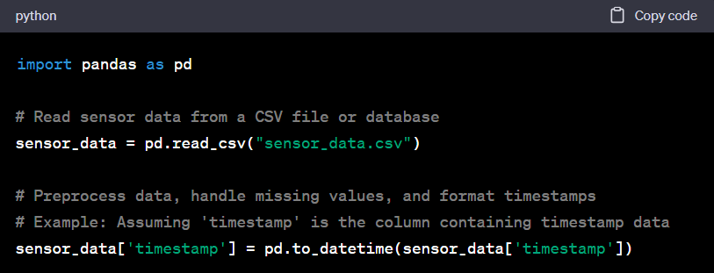

**Data Preprocessing:**

Develop data preprocessing pipelines to clean, filter, and aggregate sensor data.

Implement data transformation techniques, such as feature engineering, to extract meaningful information from raw sensor data.

**Predictive Maintenance Models:**

Choose and implement appropriate machine learning or deep learning algorithms for predictive maintenance. Common techniques include regression, classification, time series analysis, and anomaly detection.

Train models on historical maintenance data, sensor data, and maintenance logs to learn patterns of failure and maintenance needs.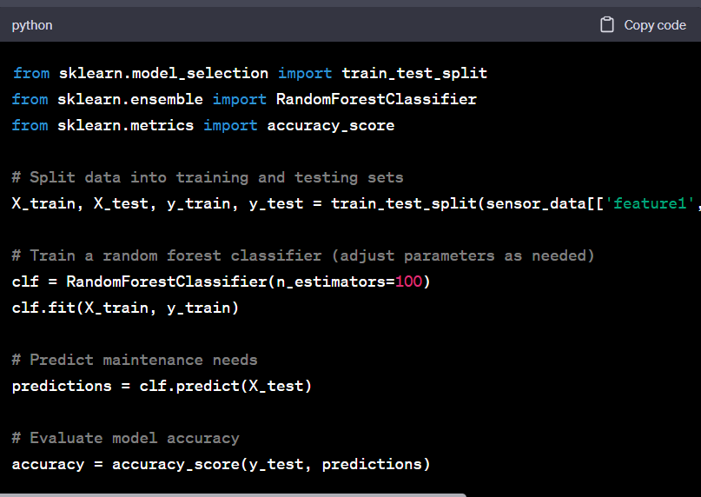

**Real-Time Monitoring and Alerts:**

Integrate predictive maintenance models with your real-time transit information platform to continuously analyze incoming sensor data.

Set up alerting systems that trigger maintenance notifications when the algorithms detect potential issues or predict upcoming maintenance requirements.

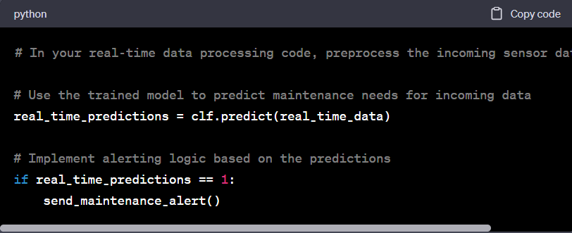

**Maintenance Scheduling:**

Develop algorithms or modules for optimizing maintenance scheduling. These can consider factors such as vehicle availability, maintenance crew availability, and the severity of predicted issues.

**User-Facing Features:**

Enhance the public-facing platform to provide passengers with information about any maintenance-related service disruptions or schedule adjustments. This ensures transparency and helps manage user expectations.

**Feedback Loop:**

Implement a feedback loop to continuously improve predictive maintenance models. When maintenance actions are taken, record the outcomes and feed this information back into the models to refine their accuracy

**Resource Allocation:**

Consider the allocation of resources for maintenance activities. Predictive maintenance can help optimize resource allocation by addressing issues when they are likely to occur, rather than relying on fixed schedules.

**Cost-Benefit Analysis:**

Perform a cost-benefit analysis to assess the financial impact of implementing predictive maintenance. Evaluate the potential savings from reduced downtime, increased vehicle lifespan, and improved operational efficiency.

**Regulatory Compliance:**

Ensure that predictive maintenance practices comply with industry and transportation regulations.

**User Education:**

Provide user education regarding the benefits of predictive maintenance and how it contributes to a safer and more reliable transportation system.

**Continuous Monitoring and Improvement:**

Continuously monitor the performance of predictive maintenance algorithms and make adjustments as needed to improve accuracy and reduce false alarms.